CN Assignment-01

By-Jeetu Mehra
U24AI032

Question 1 : Study network configuration commands and execute them on your system. For Example:
1. IPCONFIG :
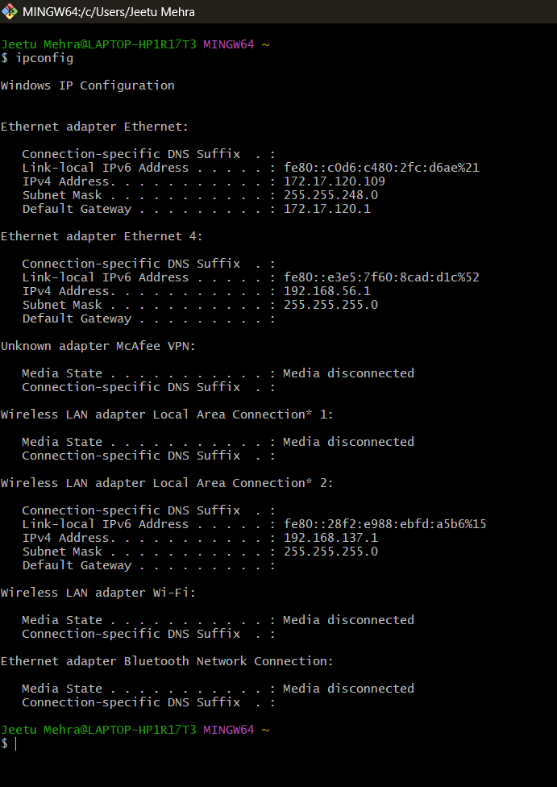
Output:

2. NSLOOKUP :
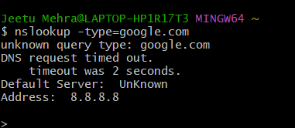
Output:

3. HOSTNAME :
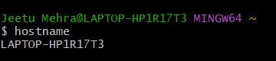
Output:

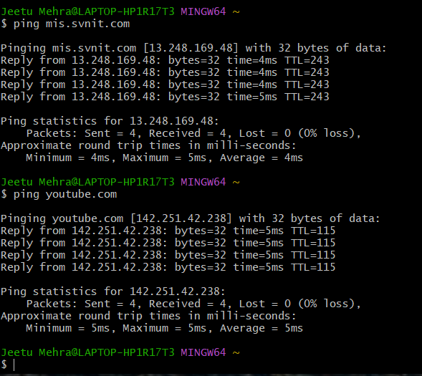
4. PING :
Output:

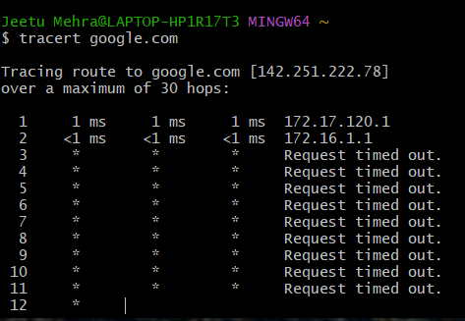
5. TRACERT :
Output:

6. NETSTAT :
Output:
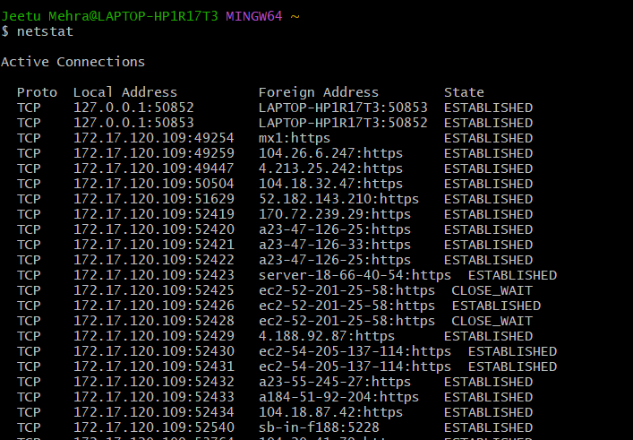

7. ARP(Address Resolution Protocol)
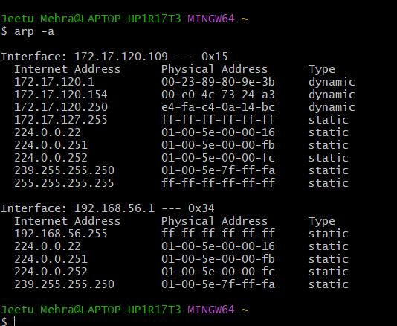
Output:

8. SYSTEMINFO
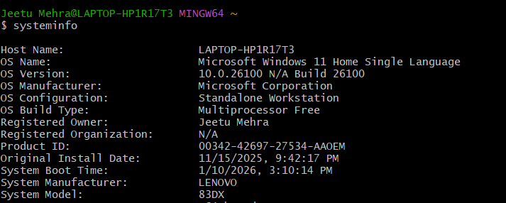
Output:

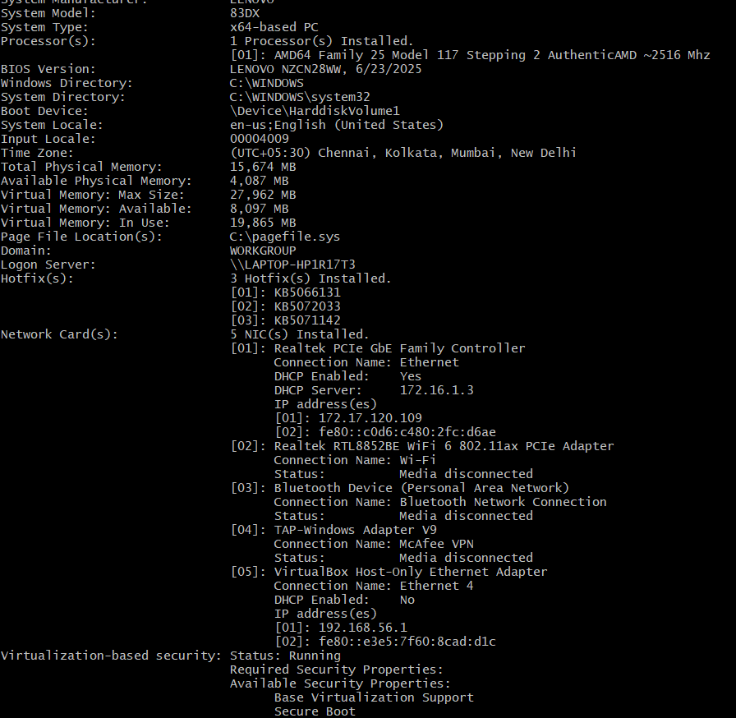

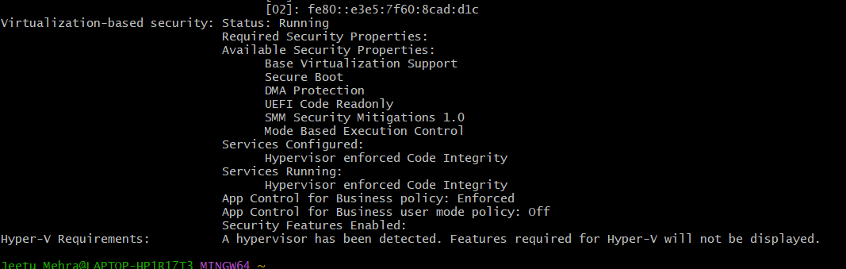

2) Explore computer network setup.
Computer Network Setup
● A computer network connects devices to share data and internet.
● Main components: Device → NIC → Router (gateway) → ISP → Internet.
● Each device has an IP address, MAC address, and hostname.
● Router assigns IPs (DHCP) and connects LAN to internet.
● DNS converts domain names to IP addresses.
● Protocols like TCP/IP manage communication.

Useful commands:
● ipconfig → IP & gateway
● ping → connectivity
● tracert → path
● arp -a → IP–MAC mapping
● netstat → active connections

